1. List the departments where the faculty members are working.

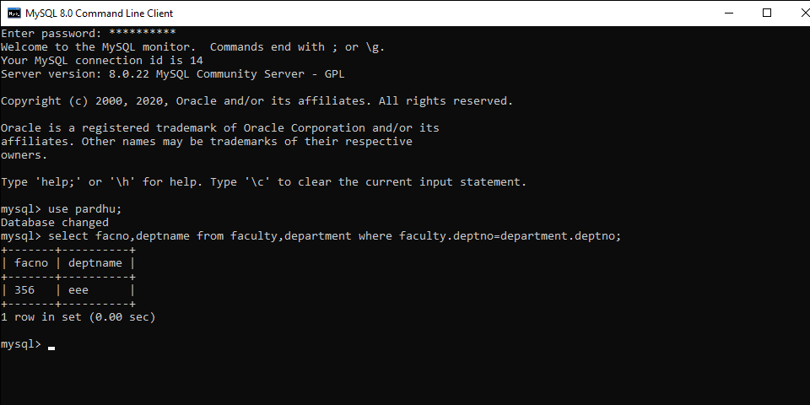

2.Find the student who has no score in any of the courses. List student name and course number

